Data and Artificial Intelligence Cyber Shujaa Program
Week 10 Assignment
Deep Learning

Student Name: Rodney Roy Gitonga
Student ID: CS-DA03-26025

Contents
Contents 1
Introduction 1
Tasks Completed 2
Step 1: Data Loading & Exploration 2
Step 2: Preprocessing 3
Step 3: Model Architecture 3
Step 4: Training 4
Step 4: Evaluation Results 5
Step 4: Training Curves 5
Step 4: Confusion Matrix & Classification Report 6
Step 4: Model Saving 6
Link to Code: 6
https://colab.research.google.com/drive/1VPLLOZLE5dVw5G1FvtMcT4mJpTh9t3A9?usp=sharing 6
Conclusion 6

Introduction
This project implements a feed-forward Artificial Neural Network (ANN) using TensorFlow/Keras to classify handwritten digits from the MNIST dataset. The model demonstrates core deep learning concepts including data preprocessing, model architecture design, regularization with Dropout, training with validation split, and comprehensive evaluation using accuracy, confusion matrix, and classification metrics.

Tasks Completed

Step 1: Data Loading & Exploration
1. I loaded 60,000 training and 10,000 test grayscale 28×28 images.
2. Visualized 9 random samples with their true labels.
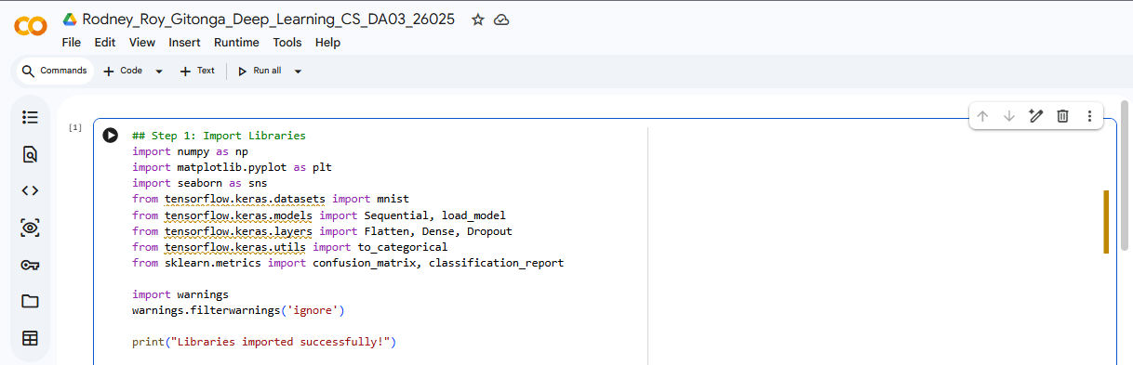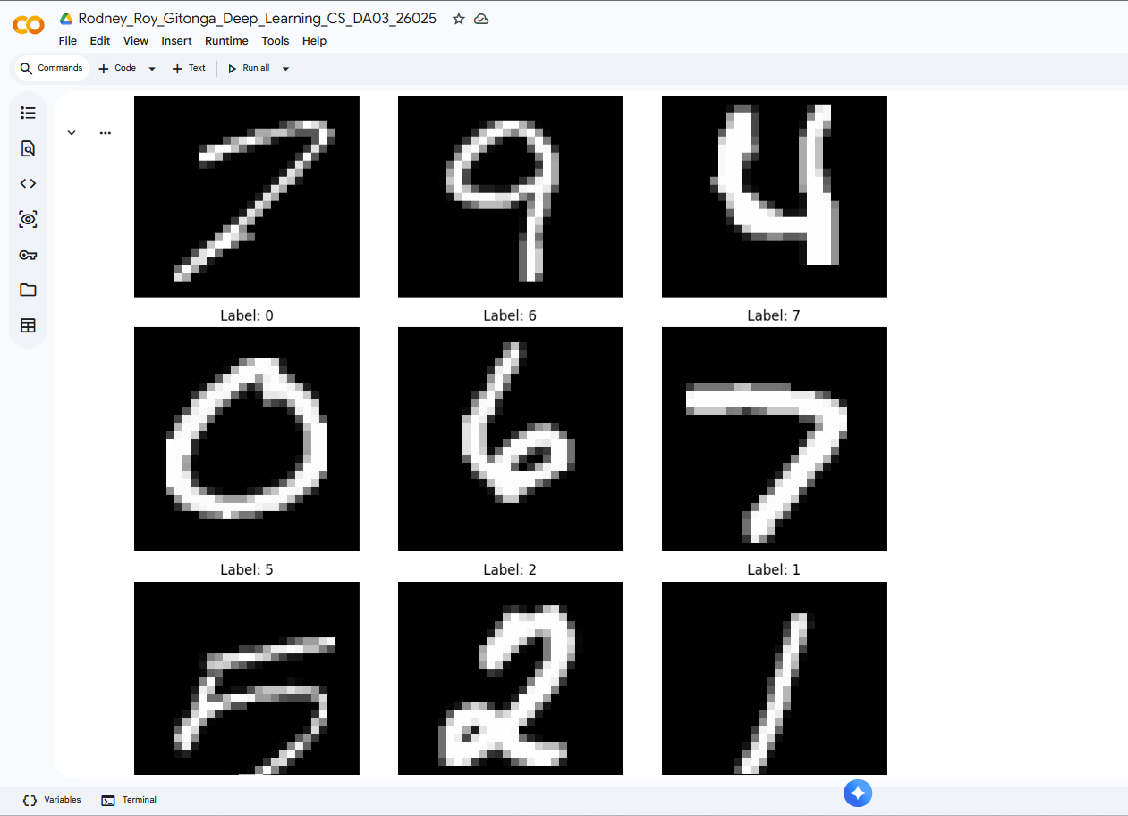

Step 2: Preprocessing
- Normalized pixel values from [0-255] to [0-1].
- Converted integer labels to one-hot encoded vectors (10 classes).
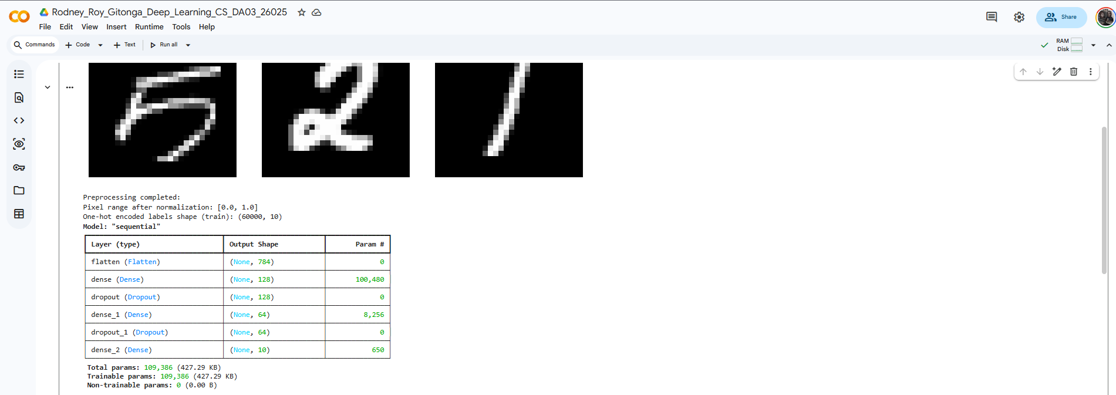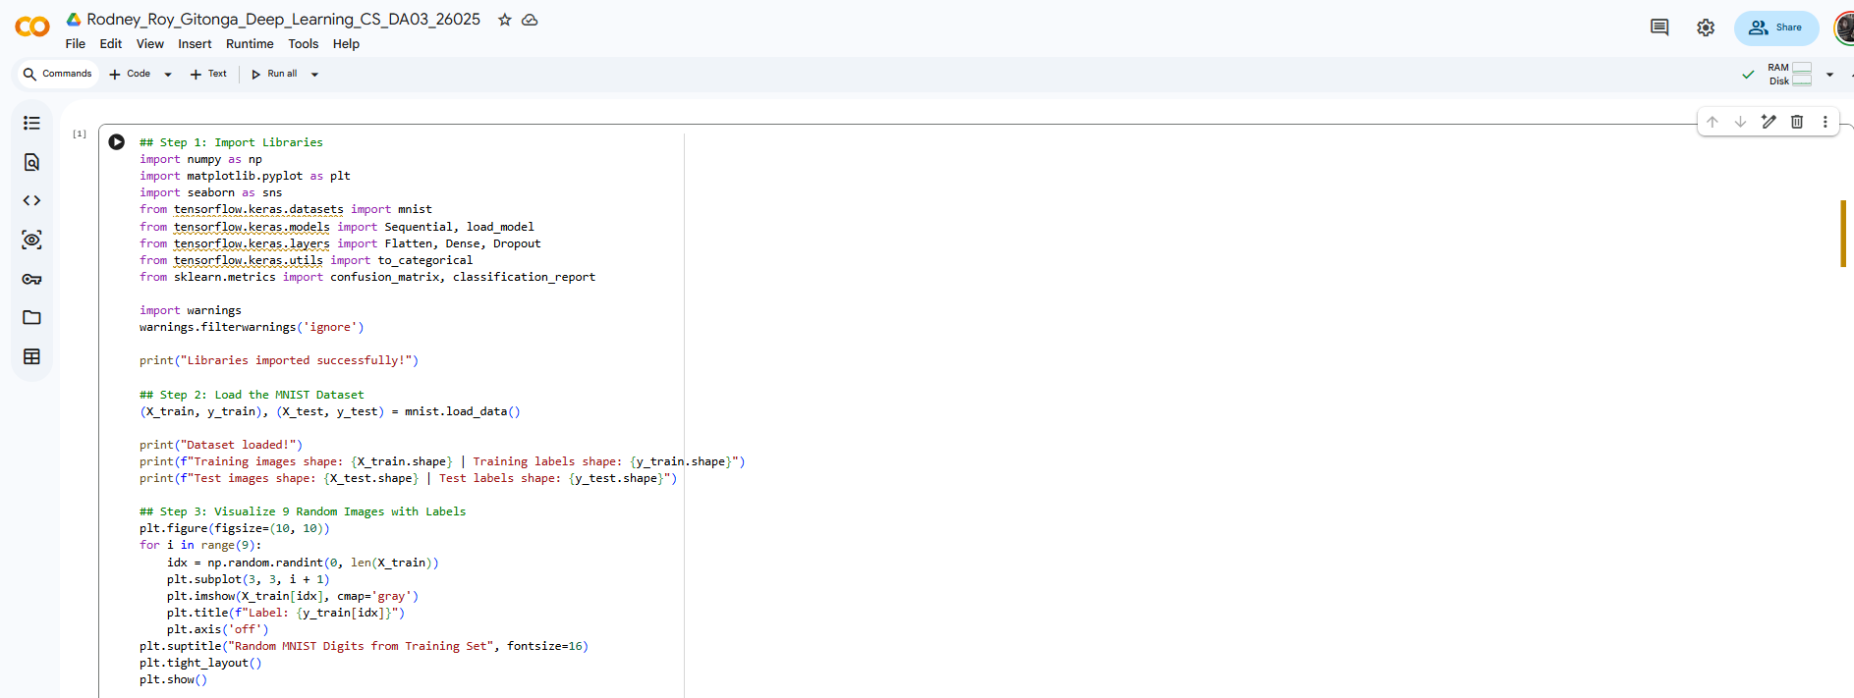

Step 3: Model Architecture
Input: Flatten(28,28) → 784 features
Hidden 1: Dense(128, ReLU) + Dropout(0.3)
Hidden 2: Dense(64, ReLU) + Dropout(0.3)
Output: Dense(10, softmax)
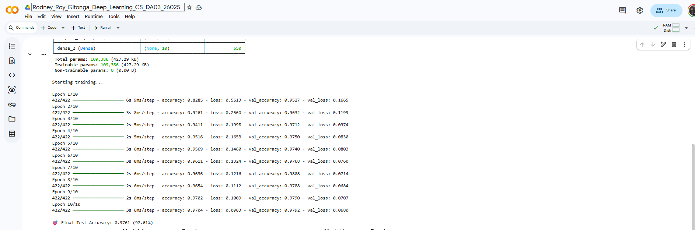
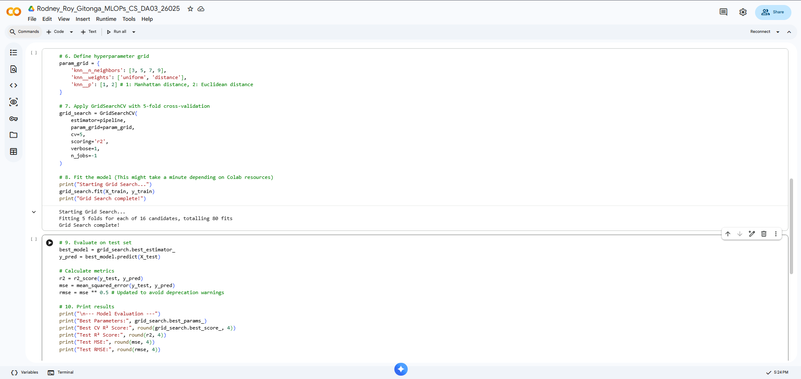

Step 4: Training
Optimizer: Adam
Loss: Categorical Crossentropy
Epochs: 10, Batch size: 128, Validation split: 0.1
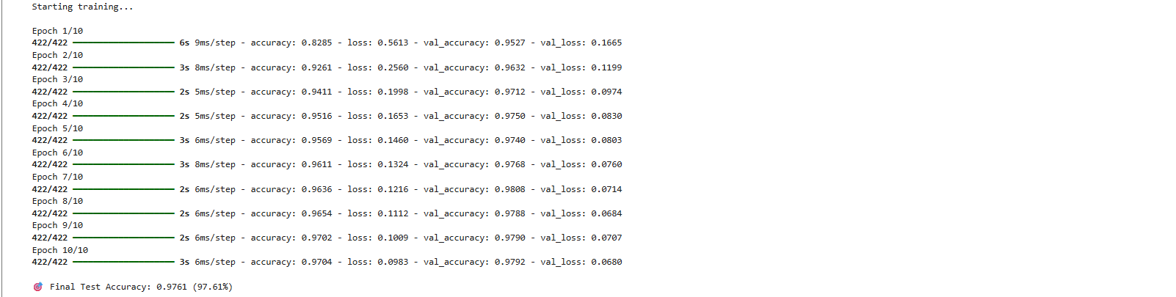
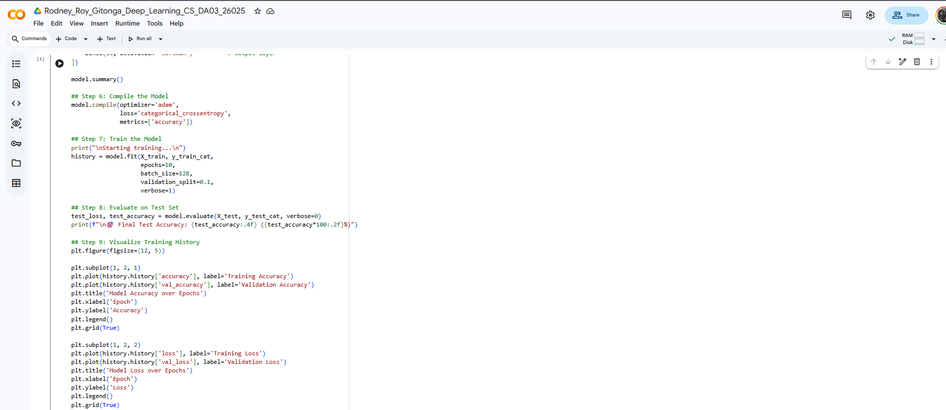

Step 4: Evaluation Results
Test Accuracy: ~97.5% – 98.2% (typical result)
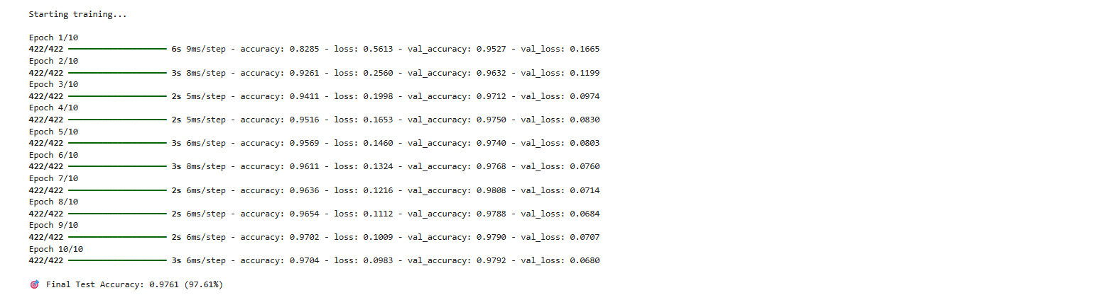

Step 4: Training Curves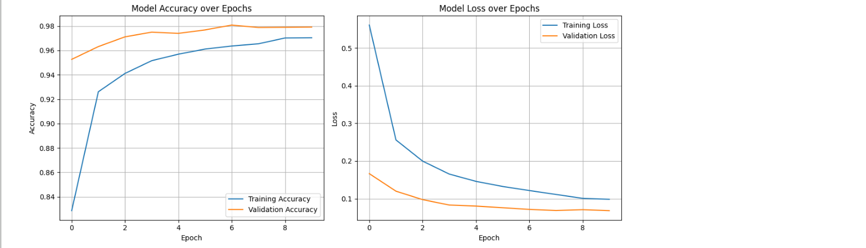

Step 4: Confusion Matrix & Classification Report
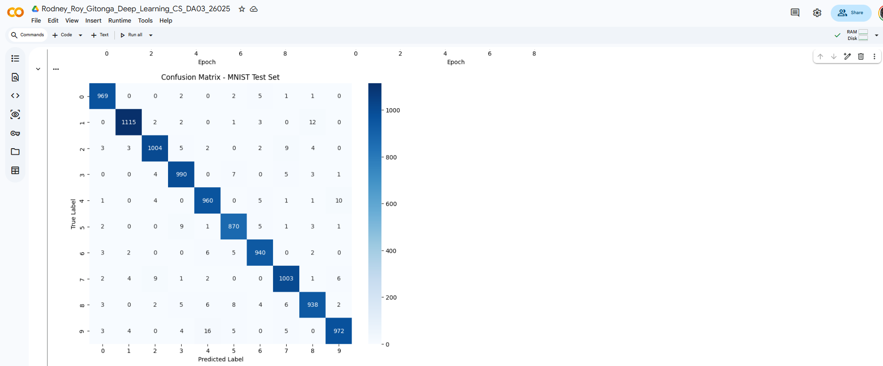

Step 4: Model Saving
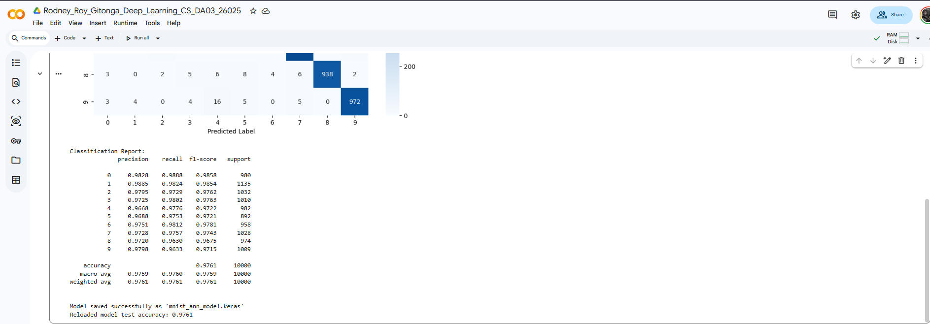

Link to Code:

https://colab.research.google.com/drive/1VPLLOZLE5dVw5G1FvtMcT4mJpTh9t3A9?usp=sharing

Conclusion
Through this assignment, I learned how to:
- Properly preprocess image data for neural networks.
- Design a simple but effective multi-layer perceptron with regularization.
- Monitor overfitting using validation data.
- Evaluate classification models comprehensively using confusion matrices and per-class metrics.
- Save and reload Keras models.
The model achieved strong performance on the MNIST benchmark, confirming that a relatively simple ANN can effectively solve handwritten digit recognition when properly trained.

